

Hand Held Mobile Biometric Terminal G-8:

APPLICATIONS  THAT  EMPOWER | 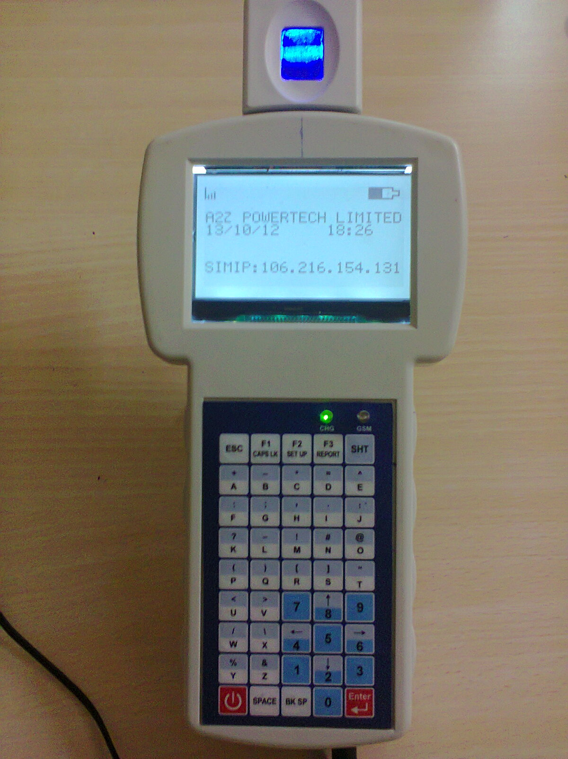

Overview:
G-18 model Mobile biometric attendance system using Lumidigm make fingerprint sensor modules extend the power and award-winning multi spectral imaging technology.

The core benefit of multi spectral technology is virtually eliminates common real world problems experienced by conventional fingerprint sensors. Fast, accurate and reliable, delivers world-class biometrics performance with highly integrated and advanced architecture.

The Mobile biometric attendance system products are able to deliver superior and unmatched biometrics performance without compromise sensor modules supports multiple modes of operation.

Multi spectral sensor technology its high performance in capturing High quality images reads the surface and subsurface to capture clear, clean images every time even when surface features are absent or hard to distinguish due to age, dirt, finger pressure, and skin or environmental conditions like Dry, wet, dirty, elderly and high ambient light.

Spoof detection: Protect against fake and spoof fingerprint by capturing detailed surface and deep tissue.

The Biometric sensor can be configured to deliver high-quality images or ANSI-378 Standard templates also be designed into either verification on (1:1) or Identification (1: N) applications and supports GSM/GPRS based data communication to server.

Mobile biometric attendance system contains interfaces LCD, Membrane keypad and that runs on a rechargeable battery. It comes with an RS232 serial/USB port/Ethernet*/GSM/GPRS to communicate with server PC.

GSM/GPRS/Bluetooth
ARM 32 bit Processor
Micro SD card
Multi Spectral
Finger Print Sensor

Salient Features:

- High accuracy and excellent verification Lumidigm multi spectral image sensor
- Best spoof detection technology.
- Enroll and verify in any environmental conditions like Dry, wet, dirty, elderly and high ambient light.
- Works in any environment rain , dry, dusty, or hot1 Touch employee recognition
- Compatible with other access control system
- Template storage of 10000
- 2GB SD memory card to store user enrolled data backup and attendance
- High Accuracy Real Time clock (RTC).
- Built in 2.2 AHr rechargeable Li-Ion batteries.
- Intelligent and fast battery charger
- Fast-Versatile-Intelligent affordable Security Lock.
- Compact - Low cost –Rugged - Light weight and dust Tolerant
- EMI/EMC compatible.

Specifications:
Processor | 32 bit High speed CPU @ 80 MHz
Display | 128 x 64 pixel graphic FSTN LCD with backlight with High clarity
Memory | 512 KB Flash memory, 128 KB SRAM, 4MB data flash,2GB SD card
FP Module | Multispectral Finger print sensor
GSM/GPRS | GSM/GPRS module Inbuilt
Interface/Connectors | - RS-232 (RJ11 Connector for console / Serial port)  - USB Device (Type B)  - Micro SD Card holder for extendable memory size
Optional | - Custom Keypad  - Customized Software  - 13.56MHz RFID Transceiver
Power Adaptor | AC Input 100-240V ±30 %, 50Hz ±10%, DC output 10.5V, 2.5Amp
LED Indications | GSM N/W, battery status
Battery | Rechargeable Li-ion 7.4V/2.2Ah
Enclosure | ABS+PC
Temperature | Operating : 0degree C to 55degree C
Humidity | 95% RH non condensing
EMI/EMC and Type tests | Comply As per IEC /IS standards
Dimensions in mm | 250 x 46 x 108 ( L x H x W)
Weight | 300 grams

Application:

The main objective of the system is to uniquely identify and to make attendance for a person in the field using Biometric finger print Scanner, who is visiting the house to house in the particular area for garbage collection.

The Device transfers data on GPRS to application Server at central Data center in both PUSH &PULL manners without any manual intervention.

The PC software will be used for restoring all the details of attendance made and generates all required MIS reports in the system.

Architecture Diagram:
a) Field Architecture:

Mobile BIO-METRIC ATTENDANCE
SYSTEM
I
I
I
I
USER 1
USER 2
USER 3
USER..n

a) System Architecture:


U
S
B
U
S
B
U
S
B
U
S
B
G
S
M
/
G
P
R
S
G
S
M
/
G
P
R
S
G
S
M
/
G
P
R
S
G
S
M
/
G
P
R
S
FIREWALL
APPLICATION
SERVER
DATABASE
SERVER
USER
M-18
M-18

M-18

M-18

I
I
I
I
I
I
I

c) PC Software:

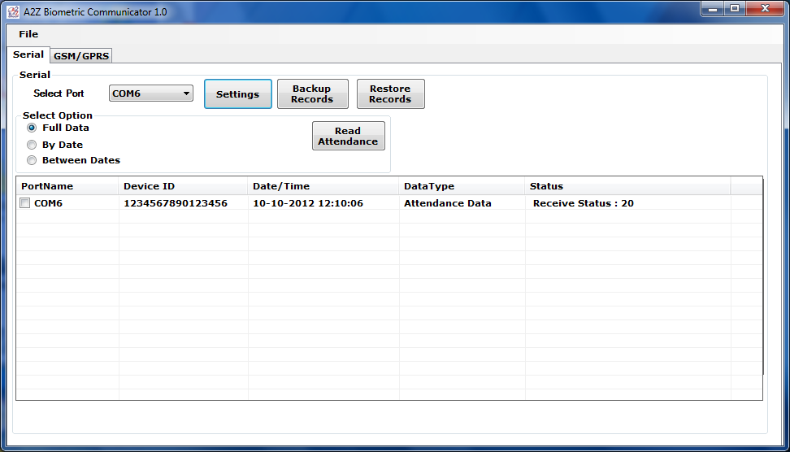

GVM Electronic Systems.

Registered office:  502, Sri sai land mark, Block-A  Street No-8,Habsiguda  Hyderabad - 500007,  Telangana (INDIA).  Website : www.gvmgroup.co.in |  | R&D Center:  1-7-9/3, Level 1 Harihara Estates,  Opp ISI, Street No. 8,Habsiguda,  Hyderabad - 500007  Andhra Pradesh (INDIA)  Tel : 040 – 40073218.

